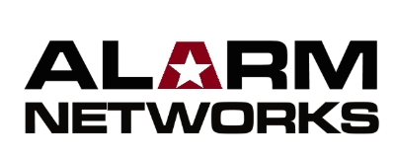
WEB ACCESS AUTHORISATION FORM

Disclaimer
This form authorises fire agents to access and manage the fire alarm systems they are responsible for through our Fire-Link web portal. By completing this form, you will be granted the necessary permissions to monitor, review, and respond to fire alarm events in real time. Access is strictly controlled and limited to approved personnel to maintain system integrity.

By submitting this form, the applicant acknowledges and agrees that access to the web portal is granted solely for the purpose of monitoring and managing assigned fire alarm systems. Unauthorised use, sharing of login credentials, or access beyond assigned permissions is strictly prohibited and may result in access revocation and/or legal action.

The company reserves the right to monitor, suspend, or terminate access at any time if misuse, security concerns, or policy violations are detected. Users are responsible for maintaining the confidentiality of their login details and must report any suspected unauthorised access immediately.

By signing or acknowledging this form via email, the applicant confirms their understanding and acceptance of these terms.

*Service agent to authorise SMS messaging phone number with other AFASP

Include Messaging From
Alarm New Zealand
*Automatic Fire Alarm Monitoring
*Johnsons Controls
Number of Staff Requiring Fire-Link Web Access
1 - 20
20 - 50
50 +

Service Company
Name:
Signature: |  | Date:

